

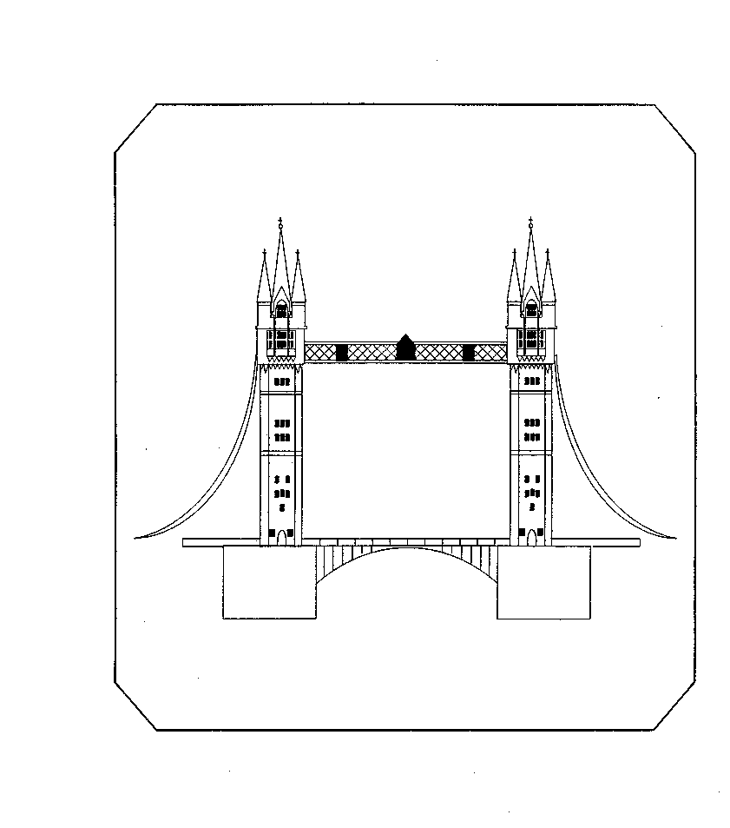
Tower Bridge Primary School  Fair Street London SE1 2AE  020 7407 2959  office@towerbridge.southwark.sch.uk  www.thebridgesfederation.org.uk | Snowsfields Primary School  Kirby Grove, Bermondsey, SE1 3TD  020 7525 9065  general@snowsfields.southwark.sch.uk  www.thebridgesfederation.org.uk

To Parents/Carers of Children in Year 6 5th September 2018

Dear Parents/Carers,

As you may be aware, we offer the children at both Snowsfields and Tower Bridge Primary Schools the opportunity to go on a two night residential trip when they are in Year 6. The residential centre that we go to is called, PGL Windmill Hill Educational and Adventure Centre and is located in Hailsham, East Sussex - http://www.pgl.co.uk/en-gb/adventure-holidays​.

We have secured 48 places (total for both schools) at this popular venue from:

Wednesday 10th – Friday 12th July 2019

Previously the school heavily subsidised this trip, but due to recent budget cuts we are not able to reduce the cost as much as we would like. The cost for this trip, which includes transport to and from the centre, all activities, accommodation, all meals and insurance, is £320.00 per child. However, we are pleased to be able to reduce this amount to £200.00 per child, school will pay the additional amount.

To help you spread the cost, we have arranged a payment scheme whereby you will need to pay a £30.00 non-refundable deposit by Friday 21st September 2018 to secure your child’s place. You can then pay £10.00 every Friday starting on Friday 5th October 2018 up to and including Friday 15th February 2019 (not including half term or Xmas holiday) to pay the balance of £170.00. You may also pay the deposit and then pay the balance in full by 15th February 2019 or pay the total amount in full when booking.

If you would like your child to attend but feel you have difficulty with the cost, please come and speak to Michelle in the school office.

Places will be allocated on a first come first served basis, however, if your child secures a place and their behaviour is a cause for concern during the school year, the school reserves the right to withdraw the offer of a place on this residential trip. A full refund will be given in this instance.

If you wish to cancel your child’s place you will still be liable for the full amount of £200.00 as we are unable to cancel any places with the company once we have confirmed our booking.

Yours sincerely


Kate Wooder
Executive Headteacher

PGL RESIDENTIAL TRIP – Wednesday 10th to Friday 12th July 2019

I give my permission for my child _____________________________ to go to PGL Windmill Hill, East Sussex.

Payments will be made as follows (please tick one box only)

I enclose £30.00 non-refundable deposit and will make weekly payments of £10.00 from 5th October 2018 – 15th February 2019 (not including half term or Xmas holiday)

I enclose £30.00 non-refundable deposit and will pay £170.00 lump sum by 15th February 2019.

I enclose full payment of £200.00

I agree that if I wish to cancel my child’s place I will still be liable for the full amount of £200.00 as the school is unable to cancel any places with the company once the booking has been confirmed.

I agree that my child’s place will be withdrawn if the school have any concerns regarding their behaviour and I will receive a full refund of monies already paid.

SIGNED:
DATE:

