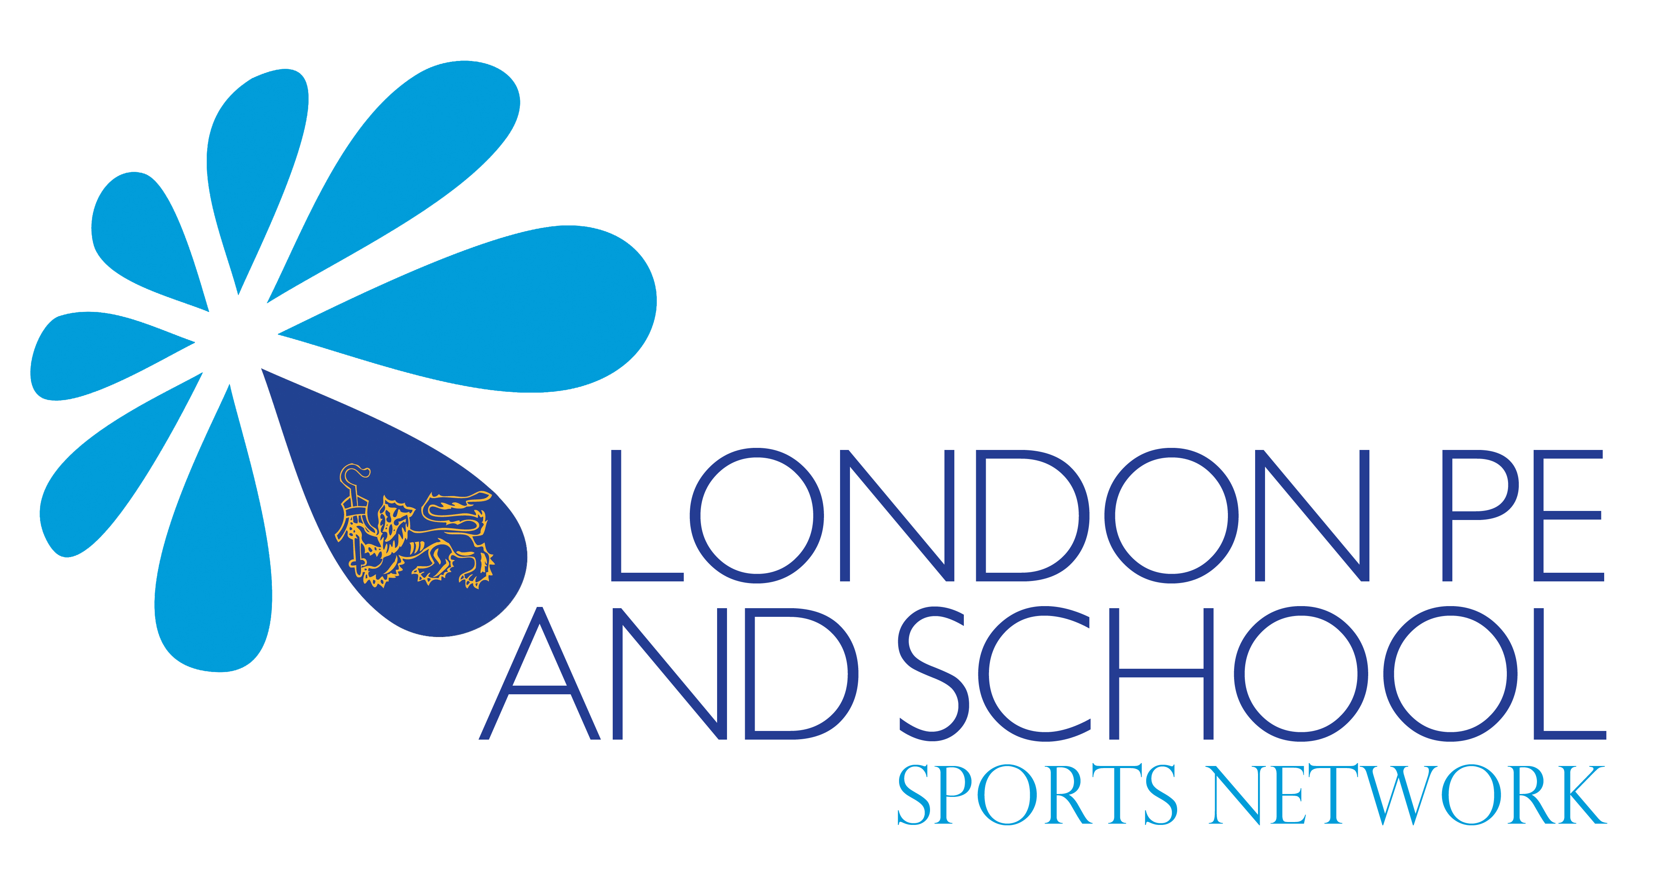

The London PE & School Sport Network

As a continued commitment to strategically developing Physical Education, School Sport and Health & Wellbeing in our school we work in partnership with the London PE & School Sport Network who are hosted at Bacon’s College, Rotherhithe, Southwark.

Through our membership we are able to access the following bespoke services, helping us ensure that our pupils have every opportunity to become the best that they can be:

- Professional development
- KS1 FUNS, real PE and Learning Nutrition training through positive partnership with Create Development
- Team teaching support in school
- Bespoke inset & staff training events including sport specific sessions and playground management
- NQT Borough Conferencing
- Bespoke advice & guidance
- Access to national projects & programmes to support the development of PE

- Leadership & Volunteering
- Access to Play Makers Award through both Borough wide conferencing and in school support
- Training of lunchtime supervisors to support play

- Competition
- School Games leading to London Youth Games
- Southwark based competition
- Key Stage One competitive experiences / festivals
- Sport specific leagues

- Health & Wellbeing
- Health & Wellbeing programme (Change 4 Life is a part of this)
- Parental nutrition workshops
- Support in achieving Healthy Schools London Status

- Special Education Needs & Inclusivity
- Team teaching programme which supports the development of inclusive physical education
- Festival of Sport opportunities

- Advocacy
- Affiliation to the Youth Sport Trust
- Opportunity to network across all LPESSN member schools
- Members of the learning community developed by LPESSN

