

## Nursery Welcome Pack

## **Home Visit:**

## **Start Date: September**

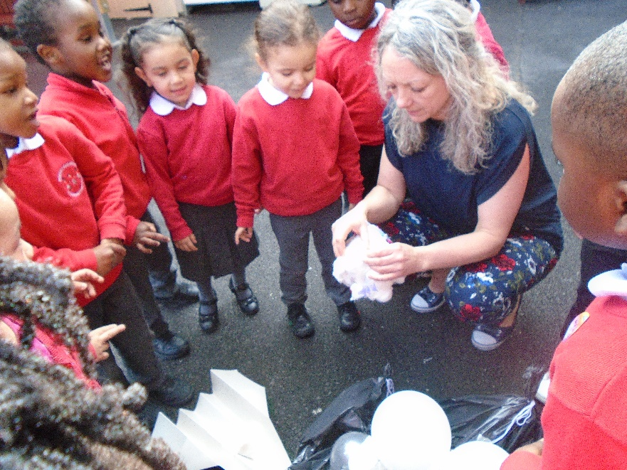

**Welcome to Robert Browning Nursery Class.**

We are pleased that you have chosen our school for your child. Here is some more information about our nursery class to help you know what to expect when your child starts.

### What are the hours of nursery?

School starts at 9am and finishes at 3.30pm. Our nursery provision is full-time Monday to Wednesday. We do not have any part-time places. Drop off and pick up is from the nursery gate on King and Queen Street. We have a slightly later start time than the rest of the school to allow for siblings to be dropped off first. It is important that you bring and collect your children on time.

### Home Visits

The nursery team will visit you and your child at your home. This is a chance for us to meet with you and your child and find out about their preferences and routines. This will support your child in settling into our school. It also allows you to ask any further questions and your child to begin to get to know the staff in your home environment.

### The Curriculum

We follow the Early Years Foundation Stage Curriculum. This has seven areas of learning including three prime areas: Communication and Language, Physical Development and Personal, Social and Emotional Development; and four specific areas: Literacy, Mathematics, Understanding of the World and Expressive Arts and Design. These are taught through topics which have been carefully planned to engage and interest the children. We encourage parents to contribute to the planning too by letting us know what your children are interested in. The first topic of the Autumn Term is ‘Ourselves’. This really helps us to get to know your child in their first few weeks of school. We will provide you with further information about the curriculum through letters home, stay and play sessions and our programme of parent workshops.

### What to bring to School

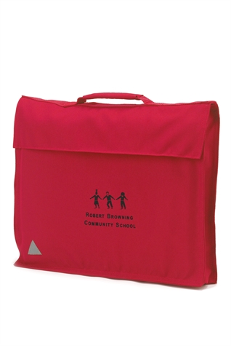Please bring a spare set of clothes to school (labelled with your child’s name) in a small bag to hang on their peg. This is in case your child has an accident or takes part in some messy play! Children need to bring their bookbag **every day** – bookbags may be bought from the school office for £4.00. Your child will use this to bring home their reading book, letters and home activities.

Please do NOT bring toys or games from home (unless asked by the teacher). Also please do NOT send your child with snacks or drinks (unless it is part of their packed lunch).

### The School Day

The nursery day begins at 9am. Children are encouraged to take off their own coats to hang on their pegs and adults can stay and play or read with their child for 10 minutes. At 9.15am the children have a short carpet session which focusses on the prime area of speaking and listening so this could be a story, game or music.

#### Focus Groups and Free Flow

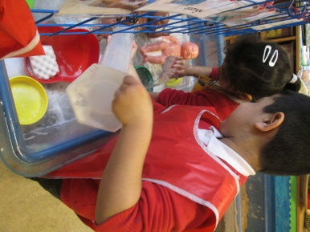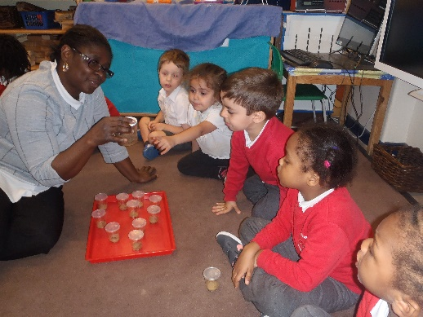After the children have sat together, they will then choose from a range of independent activities. These activities are really important in helping children to develop their skills across the curriculum. The nursery practitioners will talk to, listen and observe your child playing to assess how they are learning and to plan the next steps for each child. We use photographs and written observations stored in your child’s ‘Busy Book’ to show individual learning journeys.

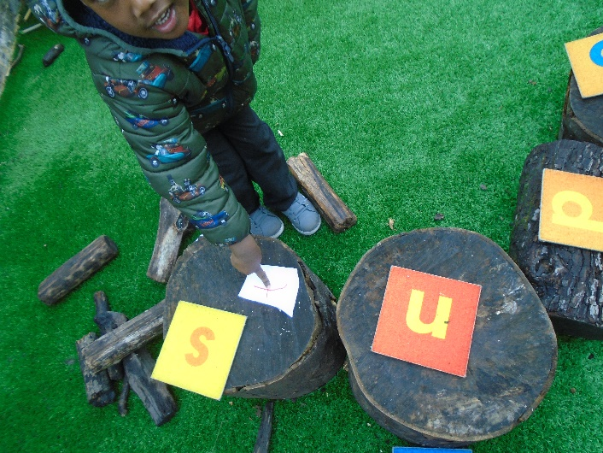

#### Outdoor Play and Learning

Outdoor play and learning are a key part of our provision. The children spend time outside every day, whatever the weather! It is important that you send your child to school with appropriate outdoor clothing so that they can access the outdoor environment. It is also helpful if they have a pair of wellies in very wet weather, at these times they should also bring their normal shoes, in a bag so they may be comfortable inside.

#### Prime Areas: Personal and Social, Communication and Language and Physical Development

We want all our children to be confident with these areas so much of what we do supports this. These are essential skills for children to be able to fully engage with the world around them allowing them to learn new skills and develop their own understanding. Communication is a key part of this and every activity we do supports the skills of listening, understanding and speaking.

#### Snacks and Drinks

During the morning the children come together for snack of fruit and can choose either water or fruit. Water is available throughout the day.

#### Lunchtime

All nursery children are now entitled to a free healthy school meal. You can also choose to send in a packed lunch, which must be healthy and balanced. An example of a healthy packed lunch would be:

* Sandwich / Rice dish
* Carrot sticks / tomatoes
* Yoghurt
* Fresh fruit / fruit snacks.

It is expected that the lunch choice is kept the same for a half term to allow your child to become used to it. Should you need to change your child’s lunch option you will need to tell the school office.

### Collection of Children at 3.30pm

Children will only be released from class with an authorised person, as identified by yourself. Should you wish for anyone else to collect your child please let us know who before the end of the school day. We request that you inform us of the name of the person collecting to ensure children are safe. We do not allow anyone **under the age of 16** to collect a child from nursery.

### Settling In

We want children to feel safe and happy in school. It is a big step for children to start at a new environment and it can take time for children to get used to new faces, surroundings and routines. After the initial 10 minutes of stay and play we advise that you say goodbye and go quickly to avoid confusion. If your child finding it hard to settle we will work with you on an individual basis to make an agreed plan of action.

#### Nursery Start Date

Home visits will be taking place in the first week of term so the nursery will be closed for this week.   
Children in nursery have different starting dates to allow for settling. Your child’s start date is at the top of this letter. Some children will be ready to begin full time very quickly, especially if they have been used to full days in another nursery, but some will need a little longer. If your child needs a longer time to transition to full days and this will be discussed on an individual basis.

### Before Starting Nursery

There are lots of things you can do at home to help your child get ready for nursery. Sharing your child’s interests at home and having conversations with them about what they like and don’t like. Spending time with groups of other children will support their social interaction especially if they haven’t been in a nursery setting before.

Help your child to become as independent as is possible by encouraging and helping them to:

* 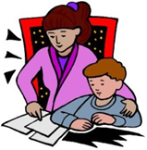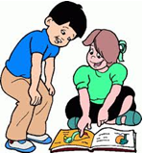use the toilet and wash their hands
* Manage their coat and shoes by themselves
* use a tissue to wipe their nose.
* share toys and take turns.
* put their toys away in the correct place

### Behaviour

Most children in nursery learn the routines and rules very quickly. Robert Browning School has five ‘Core Values’. These values are:

RESPECT ◘ INDEPENDENCE ◘ RESILIENCE ◘ CREATIVITY ◘ KINDNESS

These values are discussed in child friendly terms with the children and they underpin our expectations for behaviour.

### Supporting the Children

Each child in Nursery is assigned a key person who will support with settling, pastoral care and planning for individual needs. If you are concerned about your child’s development or progress please let us know and we will make some time available to talk to you



**Anna Mulhern** is Deputy Head and leads the Inclusion team. She works closely with Helena Oliveira to ensure that those children with additional needs, including SEND, EAL and Gifted and Talented, have the support that they require.



**Helena Oliveiro** is theInclusion Officer works with Anna Mulhern to ensure children with additional needs are given appropriate forms of support.

### Learning Journeys

Your child’s interests and achievements are recorded through observations and photographs added to their Busy Book. These books are available for you to have a look whenever you like.

When the children start school the first two weeks are a period of observation and assessment. This enables us to gain a picture of what children can already do and their personal interests.

### Homework

We want to work in partnership with you. Children make more progress when their parents are working closely with the school. We expect you to read with your child regularly and talk with them about the book. When they are ready they will be given a reading journal so you can share your thoughts with us.

### Sickness and Absence

We want your child to attend school every day so that they do not miss out on their learning. If your child is sick and unable to attend please telephone the school office by 9.00am to report their absence.

### Parent/Carer Workshops

We hold regular parent and carer workshops to share information with you about the curriculum and how you can help at home. We hope you will be able to attend these.

### How We Keep In Touch

#### About your child’s development

* Through ‘Stay and Play’ where you are able to discuss your child’s progress and share your experiences.
* You can request to meet your child’s teacher at a convenient time.
* Parents / carers are invited to Pupil and Parent Review Meetings twice a year where we will discuss your child’s progress in depth.

#### About the school

* Regular newsletters are sent out - please check your child’s bookbag for these.
* General information and news can be found on the school website.

### Uniform

Please help your child to become independent with their own dressing (this is a prime area of learning in the curriculum). Make sure they can manage their own trousers or skirt when using the toilet. Grey trousers with an elasticated waist are best. Teach them how to fasten their coat or jacket. If your child cannot tie laces – please don’t give them shoes with laces, they quickly become a hazard in nursery.

Please ensure that all clothes are named so that they do not get lost.

### Allergies and Health

During the home visit we will ask you about any health conditions that your child has, such as asthma, as well as any food allergies. Please keep us updated if this changes during the year. We are not allowed to give medicine to children at school, with the exception of inhalers and other prescribed medicines. These must be labelled with the child’s name and a form completed.

### First Aid at school

We have a qualified first aider at school with the children at all times. If children have a serious accident anywhere on the body or any type of bang to the head we will inform you by telephone. Please make sure your contact information is kept up to date by letting the office know of any changes.

### Trips and Visits

Once all children are settled in the nursery we go on walks around our local area and in the summer term plan for class visits using public transport. We always need the support of parent/carer volunteers, please let us know if you would like to help us with these.

### Volunteers

We welcome volunteers at school! If you would like to volunteer regularly please ask to speak to Anna Mulhern.

### Donations

From time to time we will ask you to make donations to school to help us with our fun activities. The children learn a lot through regular cooking activities. We will ask you to donate a small amount towards ingredients. We also ask for donations such as empty boxes for our model making activities. Please look at the class notice boards to see what you can donate to help out!

### Performances and Special Events

Reception and Nursery perform a production at the end of the Autumn term. We will let you know when this will take place. We will let you know if there are any special events such as our Spring Fair or an International evening you can become involved with through our newsletter.

##### This booklet has been written to help make starting school a happy event for you and your child. This will be one of the first big steps in your child’s life and with your support we aim to make it as happy as possible. It is important that a positive partnership between parents/guardians and teachers is fostered at this early stage. We believe that your child will benefit from this co-operation between home and school.

##### We aim to provide the highest quality education in the EYFS through a curriculum, which is tailored to their developmental needs. We hope that this booklet will answer any questions you may have about the Foundation Stage, but if you have any further queries, please see a member of staff.