

## Reception Welcome Pack

## **Home Visit:**

## **Start Date: Monday 9th September**

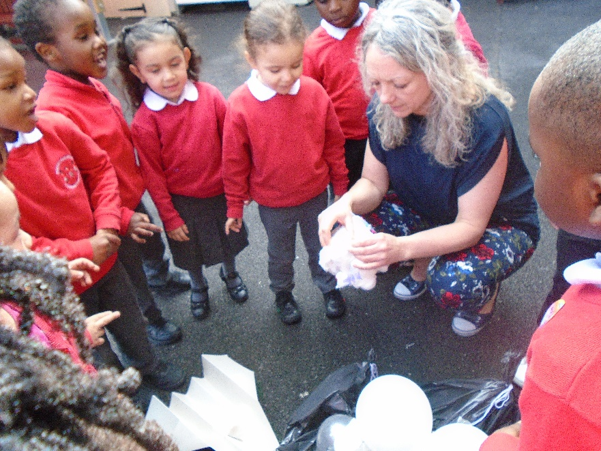

Welcome to Robert Browning Reception Class.

We are pleased that you have chosen our school for your child. Here is some more information about our Reception class to help you know what to expect when your child starts in September.

### Reception Places

School starts at 8.55am and finishes at 3.30pm. It is important that your child arrives and is collected on time.

### Home Visits

The class team will visit you and your child at your home. This is a chance for us to meet with you and your child and find out about their preferences and routines. This will support your child in settling into our school. It also allows your child to begin to get to know the staff in your home environment.

### The Curriculum

We follow the Early Years Foundation Stage Curriculum. This has seven areas of learning including three prime areas: Communication and Language, Physical Development and Personal, Social and Emotional Development; and four specific areas: Literacy, Mathematics, Understanding of the World and Expressive Arts and Design. These are taught through topics which have been carefully planned to engage and interest the children. We encourage parents to contribute to the planning too by letting us know what your children are interested in. The first topic of the Autumn Term is ‘Ourselves’. This really helps us to get to know your child in their first few weeks of school. We will provide you with further information about the curriculum through letters home, stay and play sessions and our programme of parent workshops.

### What to bring to School

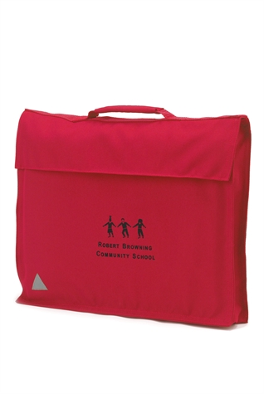Please bring a spare set of clothes to school (labelled with your child’s name) in a small bag to hang on their peg. This is in case your child has an accident or takes part in some messy play! Children need to bring their bookbag **every day** – bookbags may be bought from the school office for £4.00. Your child will use this to bring home their reading book and homework.

Please do NOT bring toys or games from home (unless asked by the teacher). Also please do NOT send your child with snacks or drinks (unless it is part of their packed lunch).

### The School Day

The Reception day begins at 8.55am when children come into class for Register. We then have a short carpet session which focusses on literacy so at the beginning of term this will often be a shared story.

#### Focus Groups and Free Flow

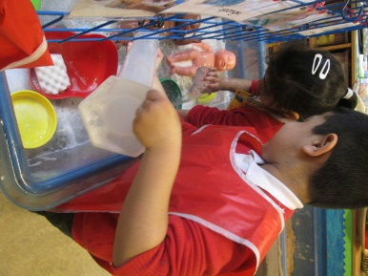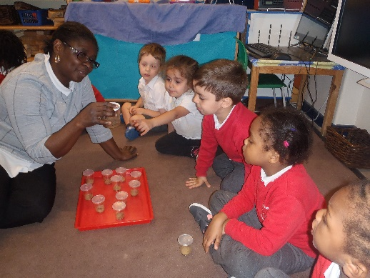After the children have sat together, they will then have the opportunity to work in small groups with a practitioner (focus groups) and to choose from a range of independent activities. These activities are really important in helping children to develop their skills across the curriculum. During these activities the practitioners will make observations, take photos of key learning and record assessments. These are used to plan the next steps for each child.

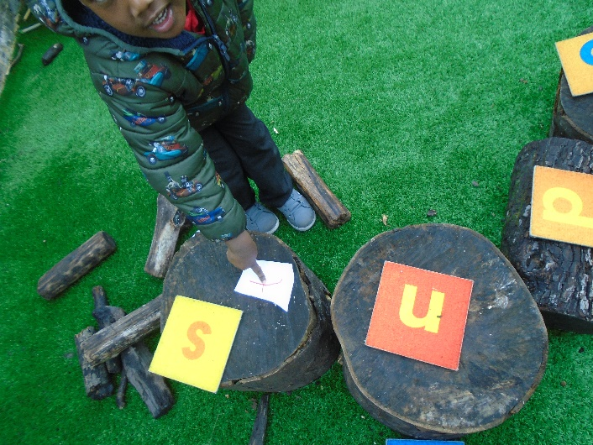

#### Outdoor Play and Learning

Outdoor play and learning are a key part of our provision. The children spend time everyday outside, whatever the weather! It is important that you send your child to school with appropriate outdoor clothing so that they can access the outdoor environment. It is also helpful if they have a pair of wellies in very wet weather, at these times they should also bring their normal, school shoes, in a bag so they may be comfortable inside.



At around 11.05am the reception children come together in the playground to take part in the daily mile before coming back together for another group session before lunch.

#### Letters and Sounds

Children will be learning their letters and sounds, to help them read and write from their first week in Reception. We will give you more information on this through Stay and Play sessions and parent workshops.

#### Snacks and Drinks

During the morning the children have access to fruit and water- they choose when to take it. They will also have the option for milk later in the day.

#### Lunchtime

All Reception children are entitled to a free healthy school meal. You can also choose to send in a packed lunch, which must be healthy and balanced. An example of a healthy packed lunch would be:

* 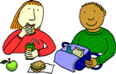Sandwich / Rice dish
* Carrot sticks / tomatoes
* Yoghurt
* Fresh fruit / fruit snacks.

It is expected that the lunch choice is kept the same for a half term. Should you need to change your child’s lunch option you will need to let the school office know.

#### Afternoon Provision

The provision in the afternoon follows the same pattern as the morning, with Group Sessions, Focus Groups and Free Flow activities. The children usually finish the day with a story and milk.

### Collection of Children at 3.30pm

Children will only be released from class with an authorised person, as identified by yourself. Should you wish for anyone else to collect your child please let us know before the end of the school day. We request that you inform us of the name of the person collecting to ensure children are safe. We do not allow anyone **under the age of 16** to collect a child from Reception.

### Settling In

We want children to feel safe and happy in school. It is a big step for children to start at a new school, particularly if they have never been to nursery. It can take time for children to get used to new faces, surroundings and routines.

#### Reception Start Date

Home visits will be taking place in the first week of term so children will come into school for their first day on Monday 9th September. We aim to have all of our Reception children attending for a full day from the first day as many are used to the full day of nursery. It is possible that some children may need a longer time to transition to full days and this will be discussed on an individual basis.

### Before Starting School

There are lots of things you can do at home to help your child get ready for school. Read some books about starting school from the library. Show them how to hold a pencil. Show them their name and help them to recognise what it looks like. Count different objects with them so they are familiar with numbers.

Help your child to become as independent as is possible by encouraging and helping them to:

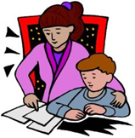

* 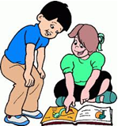use the toilet and wash their hands
* dress themselves
* use a tissue to wipe their nose.
* share toys and take turns.
* put their toys away in the correct place

### Behaviour

At school most children behave well and follow our rules and routines. Robert Browning School has five ‘Core Values’. These values are:

RESPECT ◘ INDEPENDENCE ◘ RESILIENCE ◘ CREATIVITY ◘ KINDNESS

These values are discussed in child friendly terms with the children and they underpin our expectations for behaviour.

### Supporting the Children

Each child in Reception is assigned a key person who will support with settling, pastoral care and planning for individual needs.



**Anna Mulhern** is Deputy Head and leads the Inclusion team. She works closely with Helena Oliveira to ensure that those children with additional needs, including SEND, EAL and Gifted and Talented, have the support that they require.



**Helena Oliveiro is the** Inclusion Officer works with Anna Mulhern to ensure children with additional needs are given appropriate forms of support.

### Learning Journeys

Your child’s interests and achievements are recorded through observations and photographs added to their Busy Book. These books are available for you to have a look whenever you like.

When the children start school the first two weeks are a period of observation and assessment. This enables us to gain a picture of what children can already do and their personal interests.

### Homework

We want to work in partnership with you. Children make more progress when their parents are working closely with the school. We expect you to read with your child every night and to sign their reading record book.

### Sickness and Absence

We want your child to attend school every day so that they do not miss out on their learning. If your child is sick and unable to attend please telephone the school office by 9.00am to report their absence. If you are unsure please send your child to school and let us know, we can call you if they feel worse during the day. Often children feel better when they get to school and see their friends.

### Holidays

Absence for holidays during term time cannot be authorised. If you take your child on holiday during term time you risk losing their place in school.

### Parent/Carer Workshops

We hold regular parent and carer workshops to share information with you about the curriculum and how you can help at home. We hope you will be able to attend these. They usually take place at 9.10am after you have brought your child to school.

### How We Keep In Touch

#### About your child’s development

* Through ‘Stay and Play’ where you are able to discuss your child’s progress and share your experiences.
* You can request to meet your child’s teacher at a convenient time.
* Parents / carers are invited to Pupil and Parent Review Meetings twice a year where we will discuss your child’s progress in depth.

#### About the school

* Regular newsletters are sent out - please check your child’s bookbag for these.
* General information and news can be found on the school website.

### Uniform

Please help your child to become independent with their own dressing (this is a prime area of learning in the curriculum). Send them to school in trousers or skirts that they can easily undo by themselves to go to the toilet. Teach them how to fasten their coat or jacket. Avoid laces on shoes until your child is able to tie these, this also applies to their P.E shoes.

Please ensure that all clothes are named so that they do not get lost.

### Allergies and Health

During the home visit we will ask you about any health conditions that your child has, such as asthma, as well as any food allergies. Please keep us updated if this changes during the year. We are not allowed to give medicine to children at school, with the exception of inhalers and other prescribed medicines. These must be labelled with the child’s name and a form completed.

### First Aid at school

We have a qualified first aider at school with the children at all times. If children have a serious accident anywhere on the body or any type of bang to the head we will inform you by telephone. Please make sure your contact information is kept up to date by letting the office know of any changes.

### Trips and Visits

The children go on many walks and visits in the local area. These local walks will link to the topic that the children are learning about. For example, as part of their work on transport, they may walk to a main road to take a survey of the traffic.

The children also go on planned trips involving public transport. When these take place we will write to you and let you know. We will also ask for a donation towards these trips.

Sometimes we need parent volunteers for these trips. We will let you know if you can help with this and we will give you guidance on how you can help.

### Volunteers

We welcome volunteers at school! If you would like to volunteer regularly please ask to speak to Anna Mulhern.

### Donations

From time to time we will ask you to make donations to school to help us with our fun activities. The children learn a lot through regular cooking activities. We will ask you to donate a small amount towards ingredients. We also ask for donations such as empty boxes for our model making activities. Please look at the class notice boards to see what you can donate to help out!

### Assemblies and Performances

Reception and Nursery perform a production at the end of the Autumn term. We will let you know when this will take place. We also hold regular assemblies where children are recognised for their achievements in school. You will be notified when your child is chosen and be invited to join us.

##### This booklet has been written to help make starting school a happy event for you and your child. This will be one of the first big steps in your child’s life and with your support we aim to make it as happy as possible. It is important that a positive partnership between parents/guardians and teachers is fostered at this early stage. We believe that your child will benefit from this co-operation between home and school.

##### We aim to provide the highest quality education in the EYFS through a curriculum, which is tailored to their developmental needs. We hope that this booklet will answer any questions you may have about the Foundation Stage, but if you have any further queries, please see a member of staff.