Robert Browning, Snowsfields and Tower Bridge Primary Schools
We learn and succeed together

5th November 2021

@PrimaryRobert @SNSPrimary @tbprimary Find us at: www.bridgesfederation.org.uk
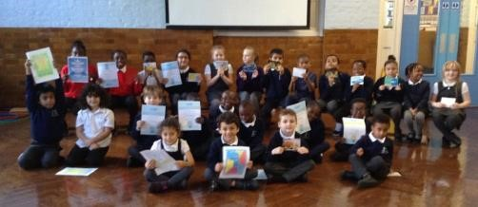
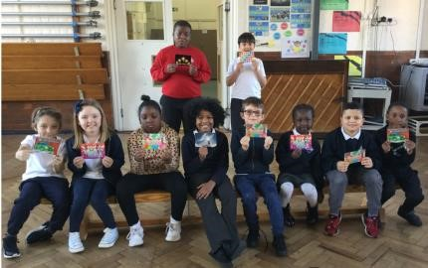
Parent Governor at Snowsfields We received a certificate in assembly this week:
Congratulations to Ali McCulloch
who you have for being fun and friendly! elected as
your Parent
Governor representative
at Snowsfields.
We are really looking for being independent learners!
forward to welcoming Ali onto our Governing Body.
Also thank you to James
Rickard and Kerry Barner for standing in this election
and thank you to everyone who voted.
Poppy Appeal!
Poppies and other Poppy Appeal Merchandise Reception Application will be on sale at school from Monday.
If you will be applying for a reception place for ^{Suggested donations:}
September 2022, the deadline for applications is ^{Poppy 50p}
Zip pull 50p 15th January 2022.
Reflector 50p
Please contact the school office if you need help. Wristband £1 https://www.southwark.gov.uk/schools-and- Snap band £1.50
education/school-admissions/primary-admissions/
applying-for-a-primary-school-place

Attendance and Punctuality
Overall whole school attendance for week beginning 18/10/21: 93.37%
1st Place Attendance: Red Class
1st Place Punctuality: Orange Class and Green Class
 | Classes | Absences | Lates | Total Attendance
 | Year 1—Red Class | 13 | 7 |  | 98.67%
 | Year 2—Orange Class | 1 | 10 |  | 96.15%
 | Year 3—Yellow Class | 10 | 8 |  | 93.85%
 | Year 4 - Green Class | 1 | 8 |  | 95.00%
 | Year 5—Blue Class | 7 | 7 |  | 96.15%
 | Year 6—Purple Class | 32 | 9 |  | 93.93%
 | A | ttendance and Punctuality
 | Overall w | hole school attendance for week beginning 18/10/21: |  | 95.19%
 |  | 1st Place Attendance: Purple Class 1st Place Punctuality: Purple Class
 | Classes | Absences | Lates |  | Points
 | Year 1—Red Class | 12 | 9 |  | 150
 | Year 2—Orange Class | 9 | 11 | 425
 | Year 3—Yellow Class | 8 | 15 | 250
 | Year 4 - Green Class | 28 | 9 | 525
 | Year 5—Blue Class | 15 | 7 | 500
 | Year 6—Purple Class | 2 | 6 | 700
 | At | tendance and Punctuality
 | Overall wh | ole school attendance for week beginning 18/10/21: |  | 90.07%
1st Place Attendance: Blue Class
1st Place Punctuality: Green Class
 | Classes | Absences | Lates | Points
 | Year 1—Red Class | 14 ½ | 33 | 175
 | Year 2—Orange Class | 19 | 21 | 50
 | Year 3—Yellow Class | 11 | 12 | 300
 | Year 4 - Green Class | 10 | 4 | 700
 | Year 5—Blue Class | 7 | 24 | 525
 | Year 6—Purple Class | 9 | 13 | 575

